Inspection document for a Rat Rod.

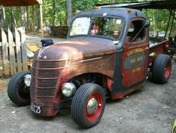

Make: International

Model: 250E Pickup Truck

Year: 1944

VIN: HN910867

Owner: Todd Fougere

Inspection document for a Rat Rod

property of:

689860 NB Ltd



Dated: 2016-07-18

Contents

1.0 Introduction 4

2.0 Volksrod modification. 5

3.0 Points to check. 5

3.1 Frame Extension 5

3.2 Brakes Lines 5

3.3 Body Modifications 5

4.0 Final Inspection. 7

# 1.0 Introduction

A Rat Rod is generally a modified car or truck that has been made cheaply and with mismatched parts, at least that is how the Rat Rods started out. They can be made with expensive engineered parts and modern safety features, however, they are still intended to look like they were made cheaply with mismatched parts. They derived from the hot rod car scene but without the fancy finishes.

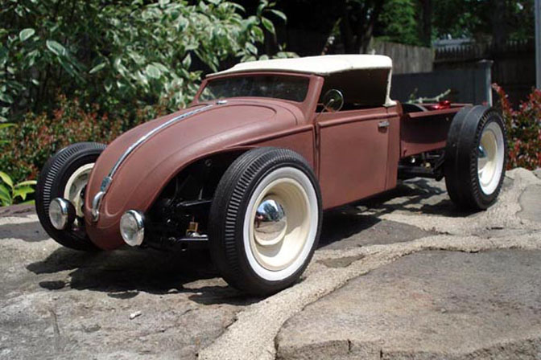

They generally involve modifying the frame to accept different axles and wheels, and sometimes involve cutting the top to lower it. The basic Rat Rod is fenderless and may not have any bumpers. Windows are also considered optional. This obviously causes issues if the vehicle is intended to actual be driven on public highways rather than just as a show or track vehicle. Depending on the jurisdiction, some of these features may have to be added to make the vehicle legal.

# 2.0 Ratrod modification.

The creation of a Ratrod may involve body modifications result in the lighting system having to be relocated. The headlights are usually replace with bug light style headlights. The interior is gutted and often the seats have all the padding removed, with just a light covering going back on. There is a lot of pride in having a finished product that looks cheap and basic.

Chopping the top is an option that would result in a mean looking vehicle, but a lot of extra work since the windows will have to be replaced. The gas tank is often replaced and may utilize a beer keg instead of the original gas tank. Since the keg is a pressurized vessel, done correctly this modification is acceptable.

# 3.0 Points to check.

The following items may be part of the Ratrod modification, in which case they need to be checked to ensure that they are safe and in accordance with requirements for on highway vehicles. If the modifications are not part of the Ratrod, they obviousle do not need to be checked.

## 3.1 Frame Extension

The extension of the frame should be done by bolting on a new extender that incorporates all the steering components. The new unit is generally stronger than the original frame, so as long as it is attached securely to the original frame it should result in a frame system that is as strong as the original.

**Check that grade 8 bolts have been used, and the original frame is still in good condition.**

## 3.2 Brakes System

If the frame has been extended, the brake lines will have to be modified to handle the longer distance from frame to brake cylinder. Also, if the original suspension and drive train has been replaced, the brake system as a whole needs to be inspected.

**Check to make sure that the brake line and hose are long enough.**

**Check that the new brake system is adequate for th vehicle, and installed correctly.**

## 3.3 Body Modifications

When the fenders are removed, certain sections of the front and rear body are also cut and shaped. This allows for the fitting of larger tires and to establish a desired look.

**Check that the new sections have been installed properly and that no jagged parts are left sticking out, and no holes that would allow exhaust into the vehicle.**

## 3.4 Lighting System

Since the lights have been removed, they will have to be relocated.

**Check that all required lights have been reinstalled, and that the new locations ensure good visibility for other vehicles and pedestrians.**

**Check that the headlights allow the driver to see at night and that they do not blind oncoming traffic.**

## 3.5 Fenders

The original fenders are removed during the modification, however for New Brunswick it is required that some form of cover be added back to prevent any stones or water from being thrown onto the windshield of the vehicle, or at other vehicles on the road.

**Check that some sort of fenders have been added to the wheels, and that they are installed in a safe manner.**

## 3.6 Bumpers

The original bumpers are often removed as part of the modification. Again, the Province of New Brunswick requires that the vehicle be equipped with bumpers.

**Check that bumpers of some sort have been added to the front and rear of the vehicle so that these are generally the first items that will connect with an object in a collision.**

## 3.7 Rear of Vehicle

The rear of the vehicle is often modified, so the exhaust system may need to be modified, and the rear latching system for the trunk will need to be modified.

**Check that the exhaust does not stick out too far, and is not redirected into a location that could result in exhaust fumes going into the vehicle.**

**Check that the trunk latches securely, and that the rear of the vehicle is generally in good condition.**

## 3.8 Front of Vehicle

**Check that the front hood latches securely, and that the front of the vehicle is generally in good condition.**

## 3.9 Proper components

Since many of the origin components will have been replaced, it is important to check that all the replacement parts are suitable for the new use. Any new glass must be DOT approved for use in a vehicle. Any new lights must be DOT approved. Any new items added to the interior must be installed such that they would not become a missile in the case of an accident.

**Check that all components are DOT approved where required, and that other components are adequately secured.**

## 3.10 Safety Features

Since Rat Rods are generally built using older vehicles, they may not require modern safety features such as seat belts. Depending on the year of the vehicle the required safety features should be checked to ensure they are installed when required.

Since comfort is not an area that can be easily tested and there are no real safety specifications for this area, the requirements for comfortable seats or drivability is not something that needs to be checked.

# 4.0 Final Inspection.

Since the whole point of a Rat Rod is for a vehicle that looks different and is built cheaply, the general look of the vehicle is not something that needs to be addressed. The look of the Rat Rod is like the look of a child; only a mother/builder may love it.

As long as the modification has been done using good quality components that are suitable for the application that they are being used for, and as long as the vehicle does not pose a danger to the occupants of the vehicle, or other people, then there is no reason to reject the vehicle.

Along with ensuring that the modification has been done correctly, the general condition of the vehicle should also be inspected. Ensure the tie rods and ball joints are good. Check that the brake shoes and or pads are good. Check that there are no holes in the body that would allow exhaust fumes to enter the interior, and that there are no body parts ready to fall off.

Assuming all the check points are good, then the vehicle can be considered as safe for operation on public roads.

Modified Rat Rod Inspection Certificate

Vehicle Make: International

Vehicle Model: 250E Pickup truck

VIN: HN910867

Vehicle Year: 1944

Description of modification:

The Ratrod was originally a 1944 International truck. It has been chopped and shortened. The original drive train has been replaced and the original suspension system has been replaced. The fenders are constructed from an oil barrel, and the hood has been constructed from a donor vehicle. The vehicle has been upgraded such that it has all the lighting requirements for todays vehicles, all the tires are covered by fenders, the engine components are covered by a hood, and the rear section of the vehicle, where the battery and gas tank are located, is also covered.

The following areas have been checked:

1. Frame Extension
2. Brake Lines
3. Body Modifications
4. Lighting System
5. Fenders
6. Bumpers
7. Rear of Vehicle
8. Front of Vehicle
9. DOT required parts
10. Safety features.

They are all either up to required standards, or not applicable to this particular vehicle. Therefore this vehicle is considered safe for use on public roads in the Province of New Brunswick.

Example of original 1944 International.